# [**‘Law & Order: SVU’ Previews Chris Meloni’s Return In Table Read Social Media**](https://deadline.com/2020/12/laworder-svu-previews-chris-meloni-return-via-social-media-posts-1234637013/)

[**‘Law & Order:SVU’ prevê retorno de Chris Meloni em leitura de mesa de media social**](https://deadline.com/2020/12/laworder-svu-previews-chris-meloni-return-via-social-media-posts-1234637013/)

By [Bruce Haring](https://deadline.com/author/bruceharingdeadline/)

December 2, 2020 8:00pm

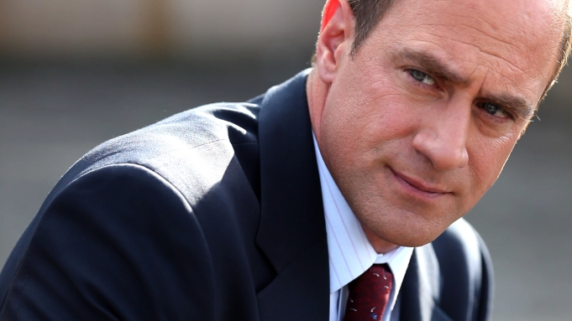

NBC

Solving any incident involves evidence. Fans of [*Law & Order: SVU*](https://deadline.com/tag/law-order-svu/) now have all the evidence they need about a special return, thanks to a tweet and Instagram shot of a virtual table read helmed by show star [Mariska Hargitay](https://deadline.com/tag/mariska-hargitay/) and showrunner [Warren Leight](https://deadline.com/tag/warren-leight/).

Resolvendo algum incidente envolve evidência. Fãs de [*Law & Order: SVU*](https://deadline.com/tag/law-order-svu/) agora teem todas as evidências que eles precisavam sobre um retorno especial, graças a uma foto Instagram e tweet de uma leitura de mesa virtual dirigida pela estrela do show [Mariska Hargitay](https://deadline.com/tag/mariska-hargitay/) e showrunner [Warren Leight](https://deadline.com/tag/warren-leight/).

[Chris Meloni](https://deadline.com/tag/chris-meloni/) will evidently return for a guest shot in his former role as Eliot Stabler if the tweet and Instagram post of the table read can be believed. Meloni was reunited at the table read with Hargitay, Peter Scanavino, Kelli Giddish, Ice-T and Jamie Gray Hyder, along with the show’s creative team.

“Well, we had a pretty good read-thru,” Leight wrote.

Meloni is going to have his own vehicle in the new franchise offshoot *Law & Order: Organized Crime*. That entry will be smoothed by appearing first on *SVU,* his first guest shot there since leaving nearly a decade ago. In the show’s world, he retired. In real life, contractual matters intervened. Apparently, all is forgiven.

Until such time as the *SVU* episode is aired and the new show scheduled, fans will have to be satisfied with the table read.

<https://pbs.twimg.com/media/EoRVlTPXUAAtNUs?format=jpg&name=small>

<https://www.instagram.com/p/CIUW-_vHXiv/?utm_source=ig_embed&ig_rid=1e04979e-ecf1-41d5-95fd-384e8e973ef0>